# Homework Assignment: There’s Snow Place Like Home Linux Challenge Or, Train Startup Challenge

Access this challenge through There’s Snow Place Like Home. 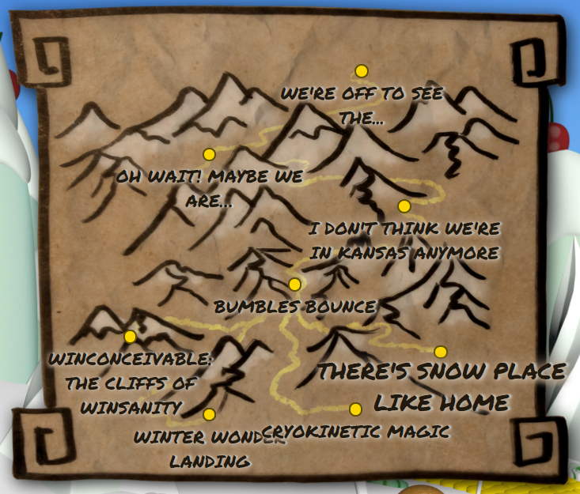

The terminal is to the right of the main gate. 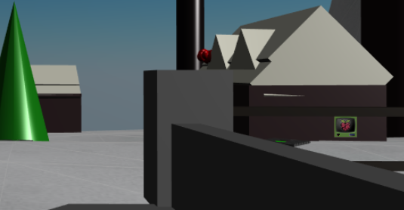

Pepper Minstix needs you to start her toy train program.

# Some Hints

This challenge will teach you a little about commands to determine file types (file), to determine the type of Linux you are running on (uname), how to determine what is installed on a Linux machine (apt), and a reminder on using help for a command.

## Step 1--try to start the program

Of course it won’t work, otherwise there would be no challenge. What error do you get? 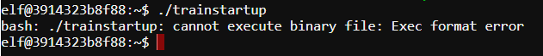

Exec format error.

Pepper’s tweet shows she is having trouble but doesn’t give a hint.

Holly’s reply is interesting. The train program is compiled for another architecture? What’s qemu?

QEMU is a generic and open source machine emulator and virtualizer, from https://www.qemu.org/

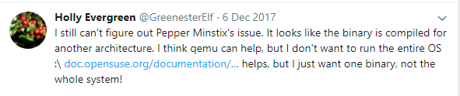

## Step 2--determine the architecture of Holly’s computer and trainstartup

A useful command for Linux users is uname. Use uname -a (-a for all info) to determine the architecture of Holly’s computer.

Use the find command to list details (including architecture) about trainstartup.

What are the architectures of the computer and trainstartup? What do we need to emulate to run trainstartup? 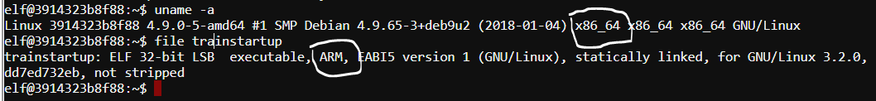

The terminal is x86-64, and trainstartup is compiled for ARM.

## Step 3--check to see if qemu is installed

Holly’s computer is a variant of Debian Linux, which uses apt and apt-get to manage program installation. Google “use apt to list installed programs” and use the results to see if qemu is installed (It helps to pipe into grep.) Is qemu installed? 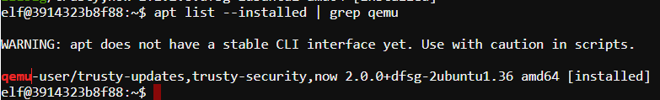

Yes, qemu is installed.

## Step 4--where is qemu and how is it used?

Use find to see if there are any programs on the computer that start with qemu (i.e., qemu*)

Is there a qemu application that looks like it would work for the architecture we need? What is it?

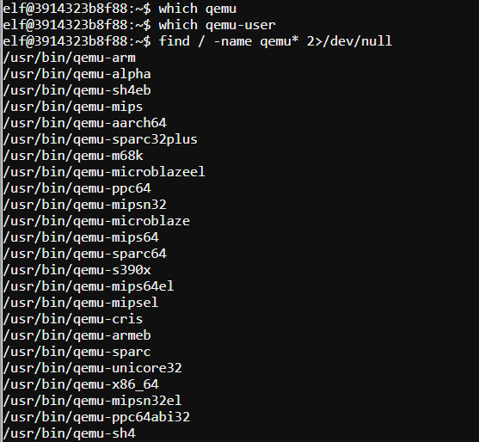 There is an app called qemu-arm, which may be what we need.

Use -h or --help to see how the qemu you need works. 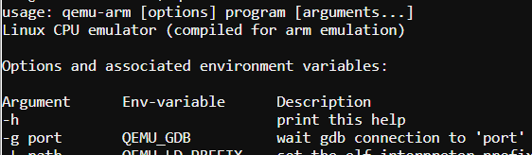

Start trainstartup. What command did you use? 

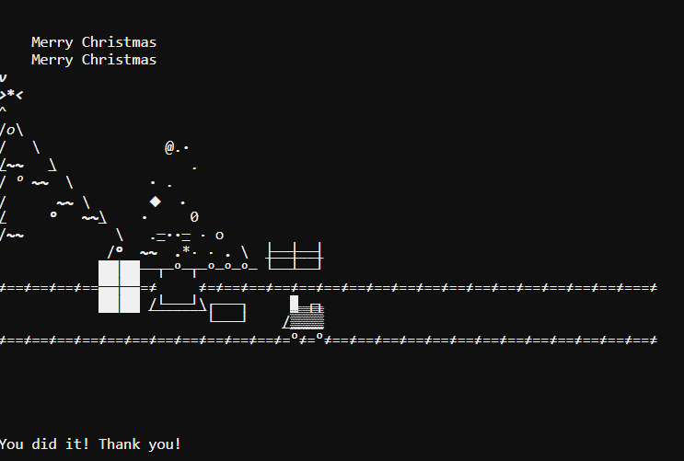

# Hand in

Hand in the answers you found to the green underlined questions.

Bonus: The error Pepper talks about in her tweet is different than the one you probably get. What is the likely mistake she made, that caused the error she saw? 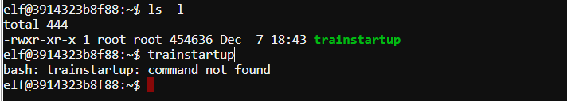

Pepper probably forgot to specify a file path.